**Hepatoprotective activities of *Autranella congolensis* and *Sapium ellypticum* against carbone tetrachloride induced liver injuries in experimental rats.**

Abdel Jelil Njouendou1, Jules Clement Nguedia Assob1, Merveille Octavie Tabouguia2, Kofia Mbarawa3, Peter Nde-Fon4, Veronique Penlap Beng2, Shrishailappa Badami5, Samuel Wanji6, Alango Pepin Nkeng-Efouet7

1. Department of Biomedical Sciences, Faculty oh Health Sciences, University of Buea.
2. Department of Biochemistry, Faculty of Science, University of Yaounde I.
3. Department of Medical Laboratory Sciences, Faculty oh Health Sciences, University of Buea.
4. Department of Public Health, Faculty of medicine and Pharmaceutical Sciences, University of Douala.
5. Sree Siddaganga College of Pharmacy, Tumkur, Karnataka, India
6. Department of Microbiology and Parasitology, Faculty of Science, University of Buea.
7. Department of Chemistry, Faculty of Sciences, University of Dschang.

**Corresponding author:** *Jules Clement Nguedia Assob, Department of Biomedical Sciences, Faculty oh Health Sciences, University of Buea, Email:* [*juleclement@yahoo.fr*](mailto:juleclement@yahoo.fr)*; P.O.Box: 12 SW Region Cameroon. Tel. : 00237 699629452/ 00237 679239483.*

# Supporting information

**Figure Suppl1**. Illustration of the mean serum parameters of animals after 10 days of treatment

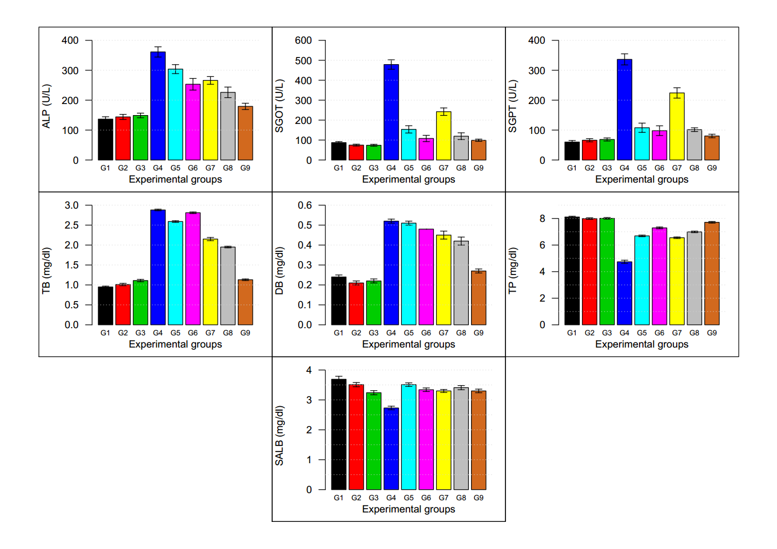

Legend:

G1: Normal control; G2: *S. ellypticum* control (200 mg/kg b.w.); G3: *A. congolensis* control (200 mg/kg b.w.); G4: Toxic control, CCl4/paraffin oil (1:1 v/v, 0.7 mL/kg, i.p); G5: SE (100 mg/kg b.w.) & CCl4/paraffin oil (1:1 v/v, 0.7 mL/kg, i.p); G6: *S. ellypticum* (200 mg/kg b.w.) & CCl4/paraffin oil (1:1 v/v, 0.7 mL/kg, i.p); G7: *A. congolensis*(100 mg/kg b.w.) & CCl4/paraffin oil (1:1 v/v, 0.7 mL/kg, i.p); G8: *A. congolensis* (200 mg/kg b.w.) & CCl4/paraffin oil (1:1 v/v, 0.7 mL/kg, i.p); G9: Silymarin (100 mg/kg b.w.) & CCl4/paraffin oil (1:1 v/v, 0.7 mL/kg, i.p); ALP: Alkaline phosphatase; SGOT: serum glutamate oxaloacetate transaminase; SGPT: serum glutamate pyruvate transaminase; TB: total bilirubin ; DB: direct bilirubin; TP: total protein; SALB: serum albumin.

**Figure Suppl2:** Illustration of the mean relative liver weight (RLW) and anti-oxidant parameters in liver homogenates after 30 days of treatment

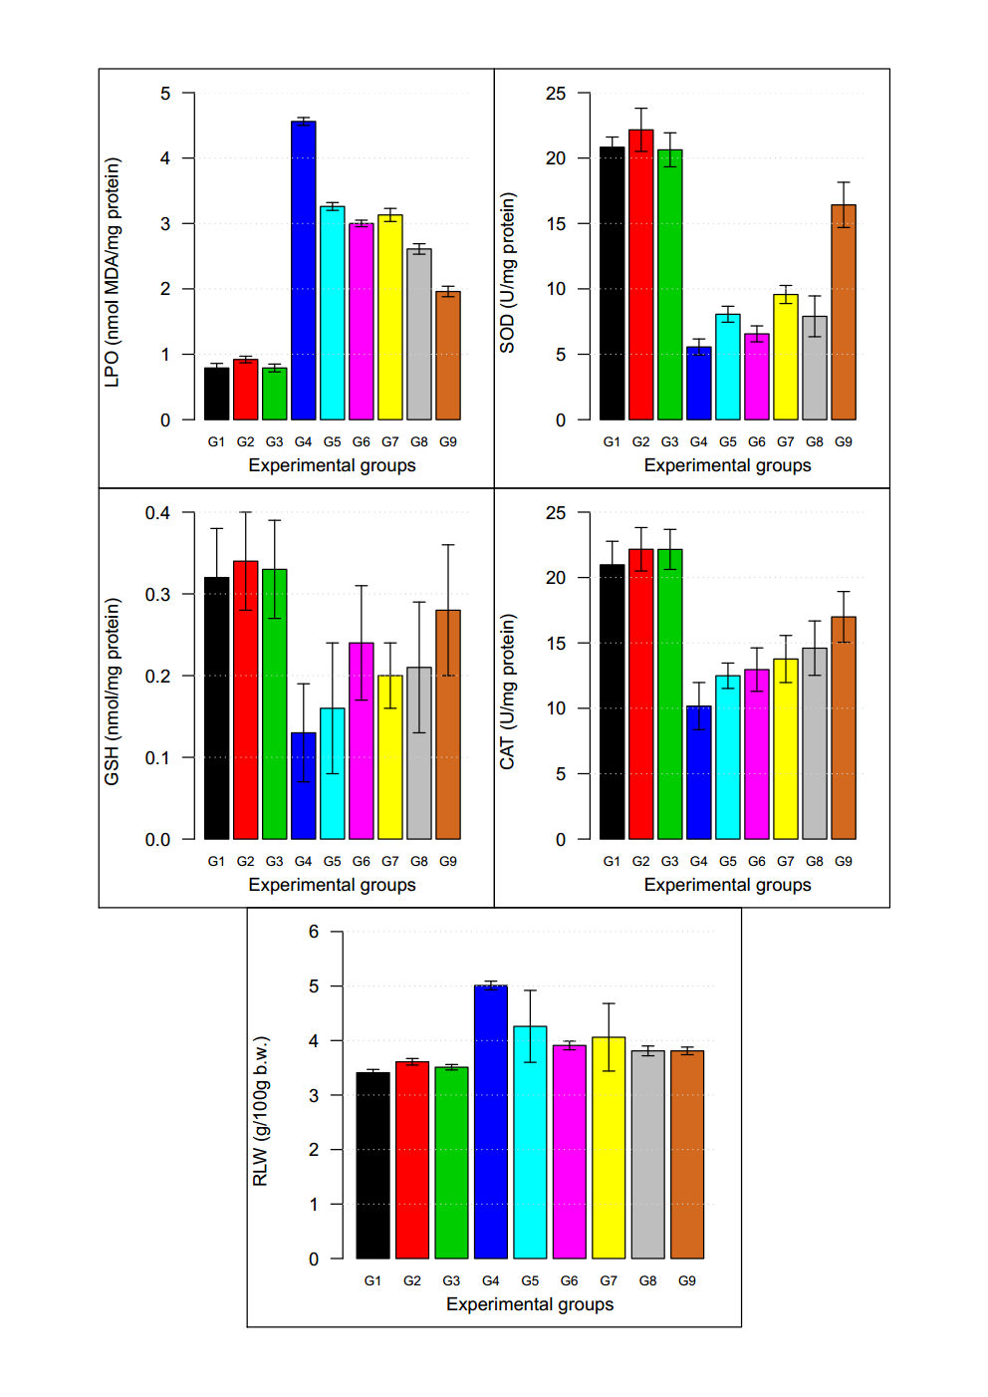

**Legend**:

G1: Normal control; G2: *S. ellypticum* control (200 mg/kg b.w.); G3: *A. congolensis* control (200 mg/kg b.w.); G4: Toxic control, CCl4/paraffin oil (1:1 v/v, 0.7 mL/kg, i.p); G5: SE (100 mg/kg b.w.) & CCl4/paraffin oil (1:1 v/v, 0.7 mL/kg, i.p); G6: *S. ellypticum* (200 mg/kg b.w.) & CCl4/paraffin oil (1:1 v/v, 0.7 mL/kg, i.p); G7: *A. congolensis*(100 mg/kg b.w.) & CCl4/paraffin oil (1:1 v/v, 0.7 mL/kg, i.p); G8: *A. congolensis* (200 mg/kg b.w.) & CCl4/paraffin oil (1:1 v/v, 0.7 mL/kg, i.p); G9: Silymarin (100 mg/kg b.w.) & CCl4/paraffin oil (1:1 v/v, 0.7 mL/kg, i.p); LPO: Lipid peroxidation; MDA: Malone dialdehyde; SOD: superoxide dismutase; GSH: Glutathione; CAT: catalase; RLW: relative liver weight.

**Figure Suppl3:** Calibration curve for liver protein titration